Customer | NOKIA
Product PN | ALC3H-8DG60959AAAD_N
Product Description | PBA 100G SD FEC LINE DAUGHTER
Product SN | EZ1340A8053
Repair ID | GERTS089019, EZ134231770

Date of issue: 18 Mai 2021
Product details:

Component details:
Material PN | ALC3-1AB227640008_REP
Material Description | OBELIX 100
Material SN or Lot Nr | N/A
Date Code or Part Mark | N/A
Supplier Name | ALTERA
Supplier PN/MPN | EP4S100G5H40I 1N

- Problem description: U9003 (PN: 1AB227640008) defective component

- Detected by: Customer field failure, failure confirmed by factory tests

- Quantity Affected: 1pcs

- Failure Message: OT minor circuit pack failure at 25°C

- Flex or Nokia analysis:
This unit failed in field at customer with “OT minor circuit pack failure at 25°C” error. Flex factory tests confirmed this error: OT minor circuit pack failure at 25°C, DAC and SFI Rx frequencies "Out of Range", OTN LOF, OTN OOF and many SFIS errors active in Tx DSP. U9003 (PN: 1AB227640008) defective component.

Replacing the component solved the problem and card passed factory tests.

- Component Physical Condition:
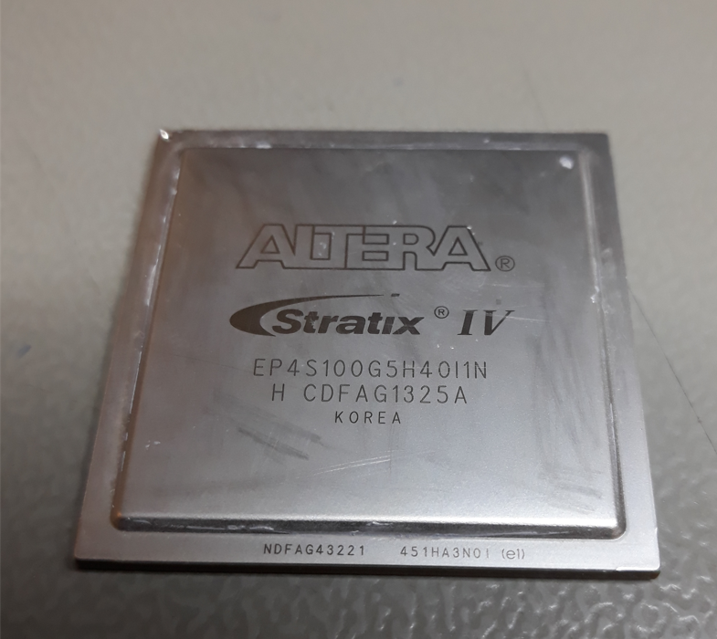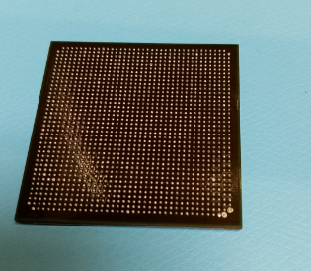
- Containment Plan

- Inspection mode: N/A
- Acceptable criteria: N\A
- Re-action: N\A
- Observation:
- Inform component supplier about this problem
- Supplier should investigate the cause of the failure

