How to run Windows GUI for AVMM DMA

Introduction
Two folders are included in the release package .zip file. The folder “Drivers” contains the driver for the PCIe HIP. The driver must be installed before running the application. Another folder is “Release_xxxx”, it has the application. Unzip the package to a local directory, double click the exe file, altera_pcie_gui.exe, in the “Release_xxxx” folder to start the application after the driver and other required software are installed.

How to install the driver
In the folder “Drivers”, there are two folders for 32-bit and 64-bit Windows. Right now, the application only supports 64-bit Windows. To install the driver, please follow the steps below.
- Unzip the package zip file and copy the folder “Drivers” into a local directory in the computer where you want to run the application.
- Go to the “Device Manager” of Windows.
- Select the FPGA and select “Update Driver Software..” by right click the mouse. If you are not sure the selected device is the FPGA, you can select “Properties” by right click the mouse, select “Details” tab and select “Hardware Ids” under Property. You should see the vendor ID is 1172.
- Browse to the folder where you copy the folder “Drivers” and select 64-bit to install the driver.

Other required software
Two additional software are needed to be installed besides the above driver. They are .NET Framework 4.5 and Visual Studio Redistributable Package 2013.
Link to get VS Redistributable package 2013
http://www.microsoft.com/en-us/download/details.aspx?id=40784
Link to get .NET Framework 4.5
http://www.microsoft.com/en-us/download/details.aspx?id=30653

How to run the application
After all the drivers and software are installed, you can run the application GUI by double click the application file altera_pcie_gui.exe in the folder “Release_xxxx”.
When the application is started, the first screen you will see is shown below.
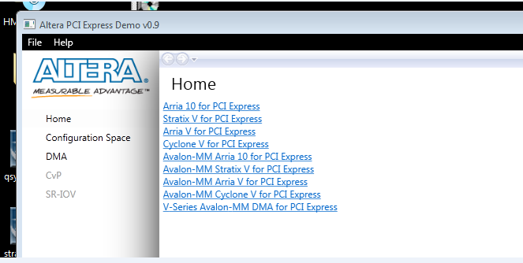
Click the “DMA” in the left list to run the DMA. Click the button “Start” at the bottom to start the DMA. The application runs both read and write DMA separately and the performance numbers are shown in the speedometer. By default, the application will run both read and write DMA for 100 iteration by using random data.
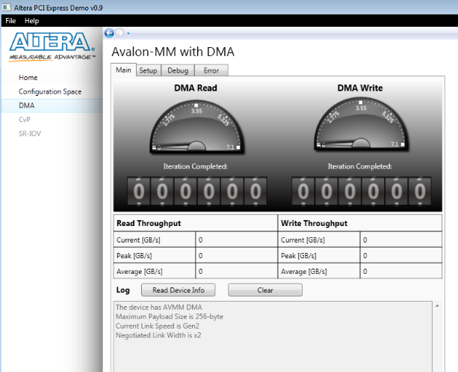
If you want to change the default settings, such as having more iterations or use different data pattern, you can select the “Setup” tab to do the change.
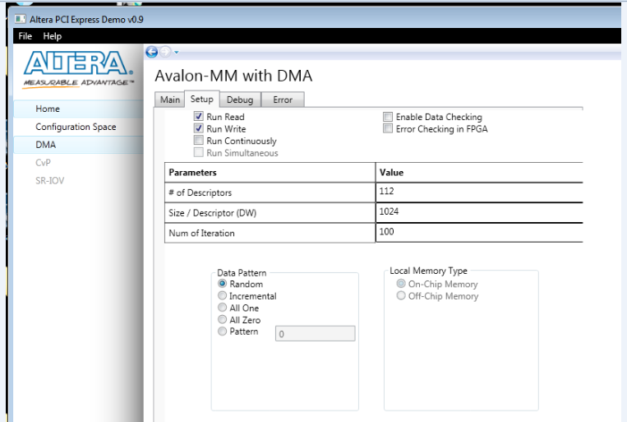
In the “setup” tab, you can also enable the data checking which does the data comparison after each read and write iteration to make sure data integrity. You can also change the number of descriptor and the transfer size of each descriptor. The option “Run Continuously” means the DMA will run forever until it is stopped by the user by clicking the “Stop” button in the “Main” tab.

