I comment the alias to little case . only use upper case.
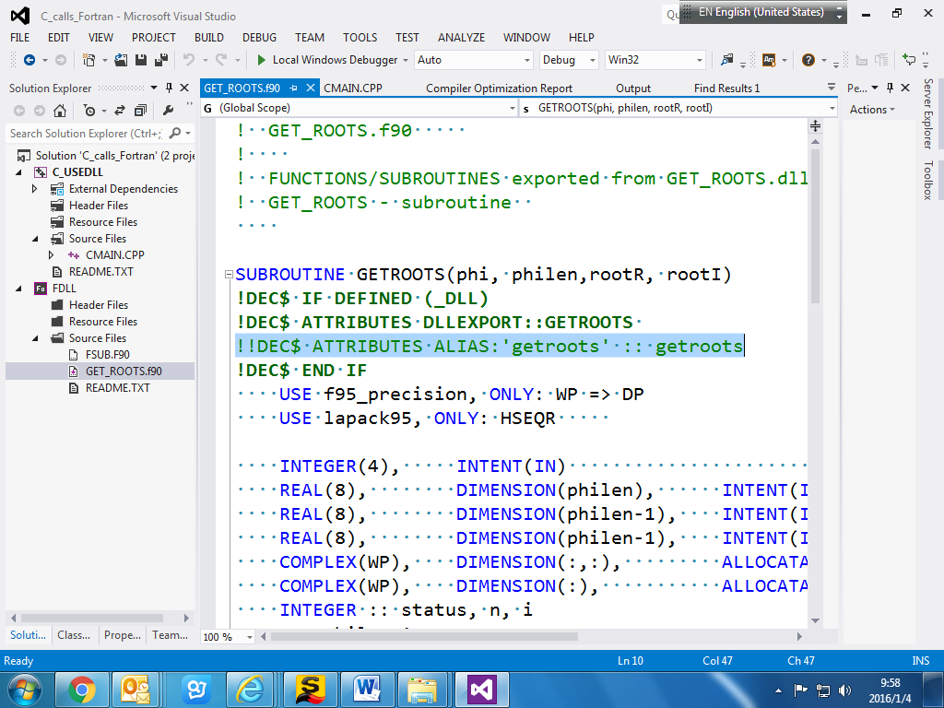

- Include path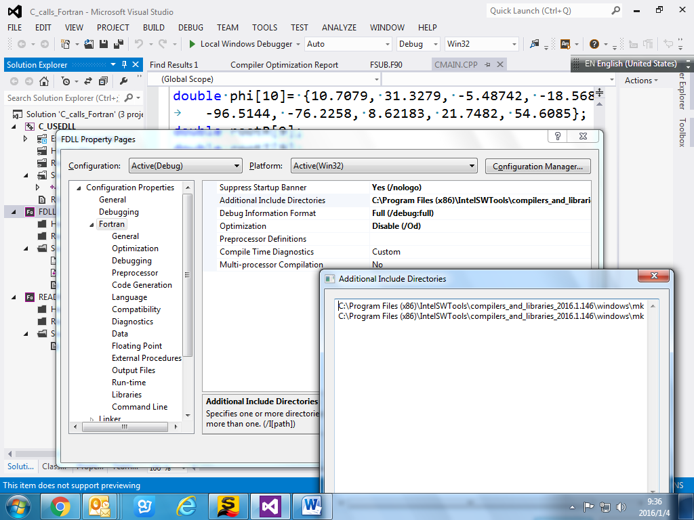
- Don’t set use mkl kernel library and keep the debug Multithread DLL

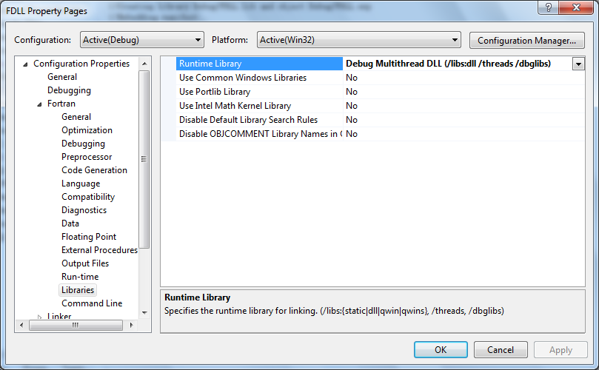
- Add mkl library path
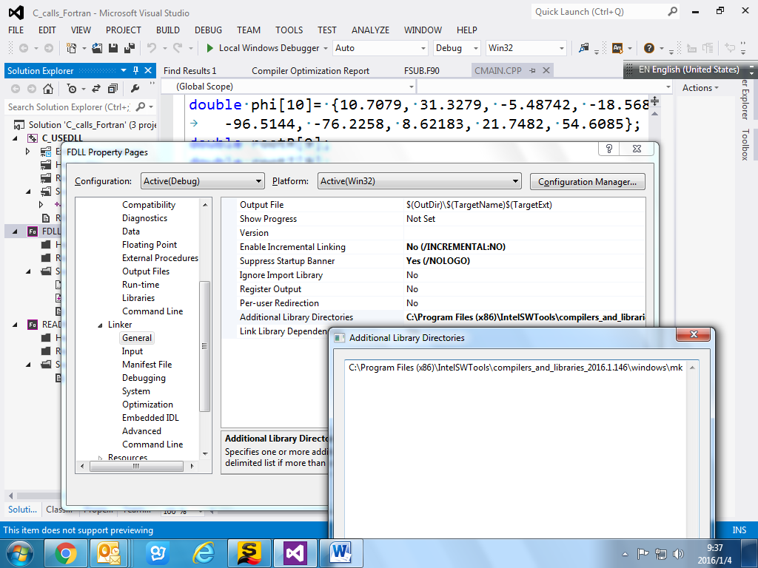
- Add mkl static library.
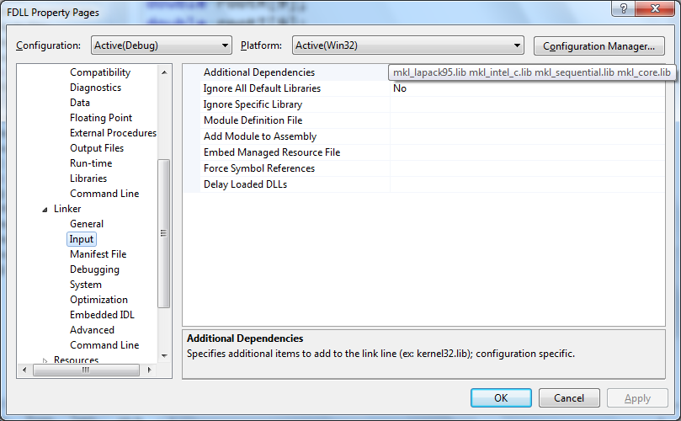

- Copy the dll into exe folder ( the project does it automatically) 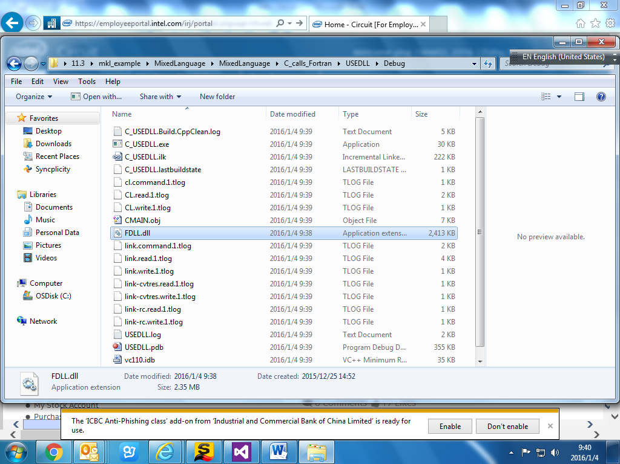

- About the dependency
Here no mkl library. So you don’t need to set mkl dll path. But if you see some run-time library from Intel Fotran library libmmd.dll, then you may need to add Intel fotran run-time library path. By default, Intel fortan dll path should be in your system path.

