IDE FREEZES EVERYTIME AND WE CAN SEE IT AS BELOW
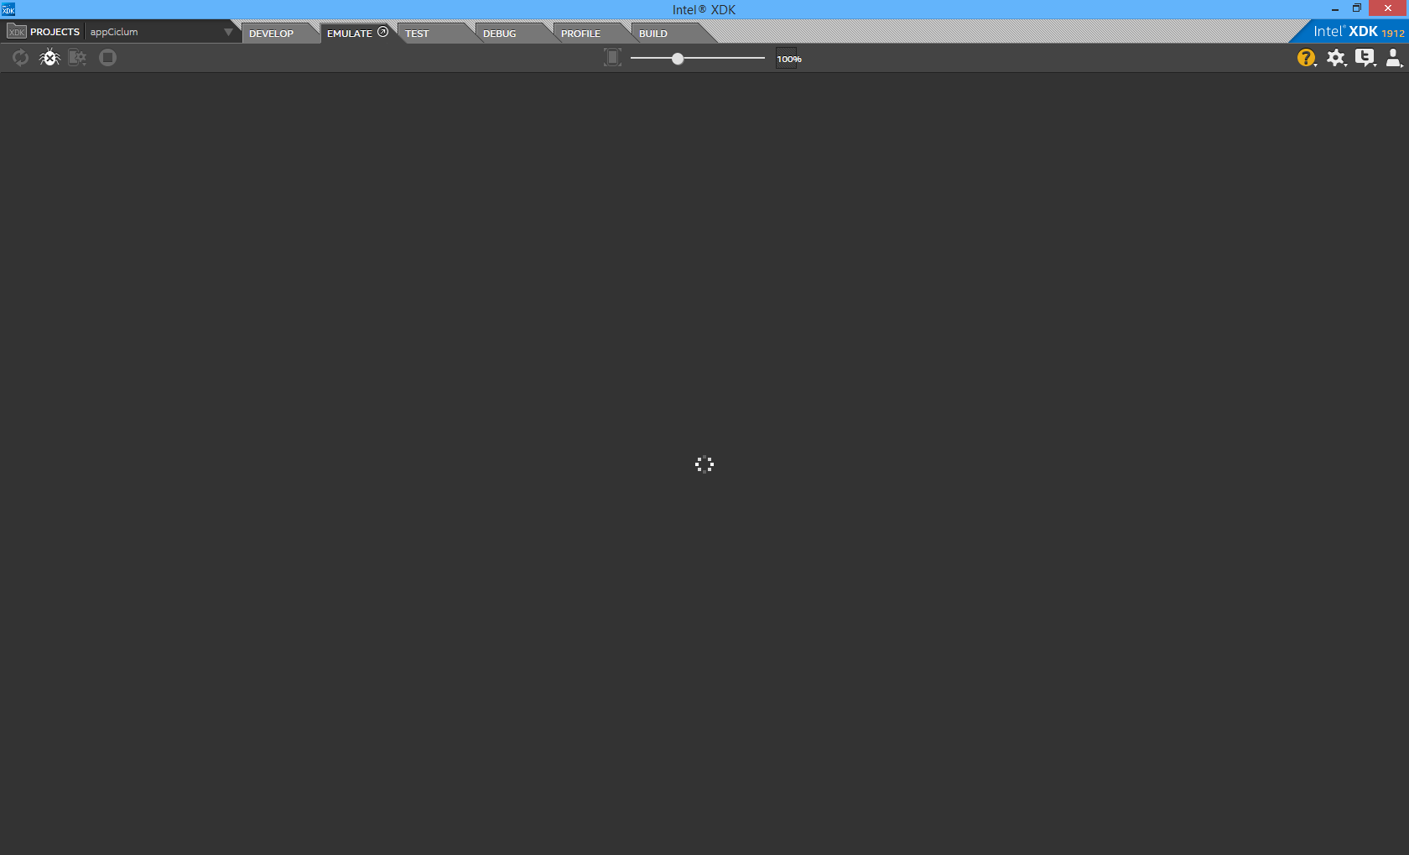

SOMETIMES I GET THIS MESSAGE. IF I HIT RESET, NOTHING HAPPENS


OTHER PROBLEMS:
- I CANT SEE BUTTONS CODE/DESIGN SOMETIMES
- I CANT SEE DESIGN MODE CLICKING IN DESIGN BUTTON
- I CANT SEE MY CSS CODE WHEN I CLICK THE NAME OF IT
- WHEN THE IDE FREEZES TRYING TO EMULATE, I CANT CLOSE DE IDE USING RED “X” BUTTON IN THE UPPER RIGHT CORNER. I ONLY CLOSE IT USING TASK MANAGER

THIS IS MY MEMORY AND CPU USAGE IN THE MOMENT I GET THE ERROR:
