Not sure which of the two thumbprints to insert into the MeBX of an Intel vPro client.
My server name is “TestLabServer.ArrowImage.com”
My RootCA is called ArrowImageCA

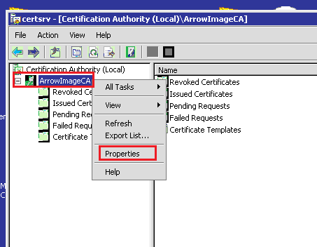
Right click on Root CA called ArrowImageCA > Properties > View Certificate
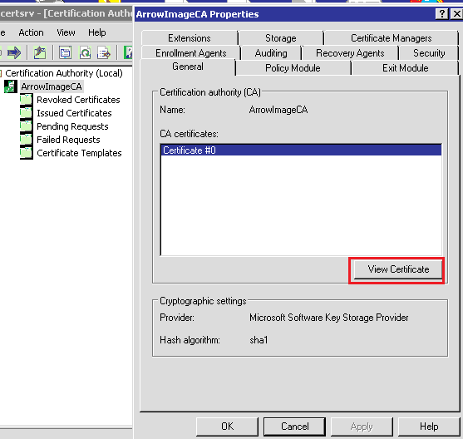
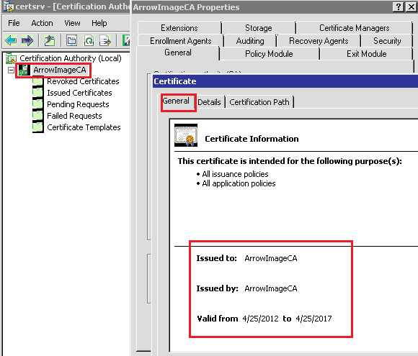
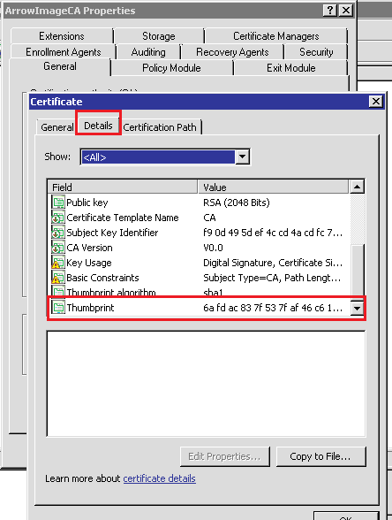

OR
